|  |  |
| --- | --- |
| Document Title | Specification of APP Driver |
| **Document Owner** |  |
| **Document Responsibility** | Esraa El-Sayed El-Beltagy |
| **Document Identification No** |  |
| **Document Classification** |  |
|  |  |
| **Document Version** | 1.0 |
| **Document Status** |  |
| **Part of Release** |  |
| **Revision** |  |

|  |  |  |  |
| --- | --- | --- | --- |
|  | **Document Change History** | | |
| **Date** | **Version** | **Changed by** | **Change Description** |
| 16.04.2017 | 1.0.0 |  | Initial Release |

**Disclaimer**

This specification and the material contained in it is for the purpose of information only. The companies that have contributed to it shall not be liable for any use of the specification.

The material contained in this specification is protected by copyright and other types of Intellectual Property Rights. The commercial exploitation of the material contained in this specification requires a license to such Intellectual Property Rights.

This specification may be utilized or reproduced without any modification, in any form or by any means, for informational purposes only.

For any other purpose, no part of the specification may be utilized or reproduced, in any form or by any means, without permission in writing from the publisher.

**Table of Contents**

1 Introduction and functional overview 5

1.1 Objective 5

1.2 Context Diagram 5

1.3 Acronyms and abbreviations 5

2 External interfaces 6

2.1 Std_Types.h 6

2.1.1 Types 6

2.1.2 Interfaces 6

2.1.3 Constants 6

2.1.4 Variables 6

3 Static Design 7

3.1 File structure 7

3.1.1 Used Files 7

3.1.2 File inclusion 7

3.2 Types 7

3.2.1 Imported types 7

3.2.2 Types Definitions 7

3.2.2.1 7

3.3 Symbol Definition 8

3.4 Function definitions 8

3.4.1 8

3.5 Call-back notifications 9

3.6 Scheduled functions 9

4 Dynamic Design 9

4.1 Mode Management 9

4.2 Sequence Diagram 9

5 Shared Resources 9

6 Configuration specification 10

6.1 Containers and configuration parameters 10

6.1.1 Variants 10

6.1.2 Parameters 10

6.1.2.1 10

7 Configuration Constraints 11

8 Integration Constraints 11

# Introduction and functional overview

## Objective

The objective of App component is to use it to measure distance and velocity then display them on LCD.

## Context Diagram

**App**

App_Task

## Acronyms and abbreviations

Acronyms and abbreviations that have a local scope.

|  |  |
| --- | --- |
| ***Abbreviation / Acronym:*** | ***Description:*** |
| App | Application |
| LCD | Liquid Crystal Display |
| Int | Integer |
| Char | Character |

# External interfaces

## Std_Types.h

### Types

|  |  |
| --- | --- |
| **Name** | **Description** |
| U8 | Unsigned char |
| U16 | Unsigned short Int |
| U32 | Unsigned long Int |
| f32 | Float |
| f64 | Double |
| S8 | Short char |
| S16 | Signed short Int |
| S32 | Signed long Int |

### Interfaces

None.

### Constants

None.

### Variables

None.

## LCD.h

### Types

None.

### Interfaces

|  |  |
| --- | --- |
| Function | ***Description*** |
| LCD_Write | This function is Used to send array to be written on the screen on the column with number Xloc and the row with number Yloc. |

### 

### Constants

None

### Variables

None

## US.h

### Types

None.

### Interfaces

|  |  |
| --- | --- |
| Function | ***Description*** |
| US_GetDistance | This function is used the measured distance and return it. |

### Constants

None

### Variables

None

# Static Design

## File structure

### Used Files

|  |  |
| --- | --- |
| ***File*** | ***Description*** |
| App.h | This file includes all prototype of function, #defines, extern constant and types of App component. |
| App.c | This file includes all functions implementation and constant of App component. |

### File inclusion

App.h

LCD.h

App.c

OS.h

STD_TYPES.h

## Types

### Types Definitions

#### 

|  |  |  |  |
| --- | --- | --- | --- |
| ***Name:*** | u16OldValue | | |
| ***Type:*** | u16 | | |
| ***Range:*** | 2-300 |  |  |
| ***Description:*** | It is variable has the old measured distance. | | |

|  |  |  |  |
| --- | --- | --- | --- |
| ***Name:*** | u16NewValue | | |
| ***Type:*** | u16 | | |
| ***Range:*** | 2-300 |  |  |
| ***Description:*** | It is variable has the new measured distance. | | |

|  |  |  |  |
| --- | --- | --- | --- |
| ***Name:*** | U32Velocity | | |
| ***Type:*** | U32 | | |
| ***Range:*** |  |  |  |
| ***Description:*** | It is variable to calculate the velocity. | | |

## Symbol Definition

None.

## Function definitions

This is a list of functions provided for upper layer modules.

### 

|  |  |  |
| --- | --- | --- |
| ***Service name:*** | App_Task | |
| ***Syntax:*** | Void App_Task (void); | |
| ***Service ID[hex]:*** | App_Service_001 | |
| ***Sync/Async:*** | Sync | |
| ***Reentrancy:*** | Non reentrant | |
| ***Parameters (in):*** | None |  |
| ***Parameters***  ***(in/out):*** | None | |
| ***Parameters (out):*** | None | |
| ***Return value:*** | None |  |
| ***Description:*** | This function is used to take the new measured distance and calculate the velocity then display it on LCD. | |

## Call-back notifications

This chapter lists all functions provided by the App module to lower layers.

App module does not provide any callback notifications.

## Scheduled functions

This chapter lists all functions called directly by the Basic Software Module Scheduler.

App_task will be called by the Basic Software Module Scheduler.

# Dynamic Design

## Mode Management

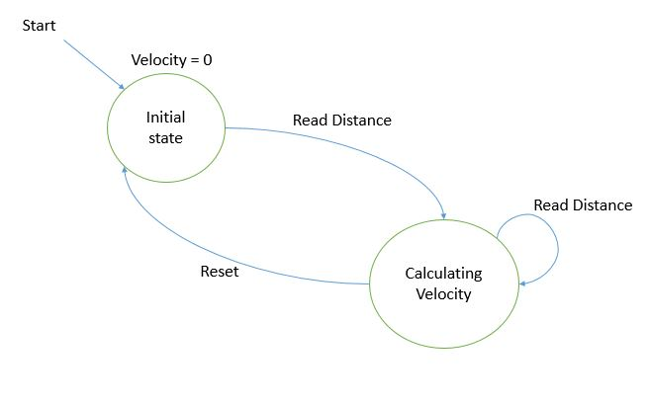

## Sequence Diagram

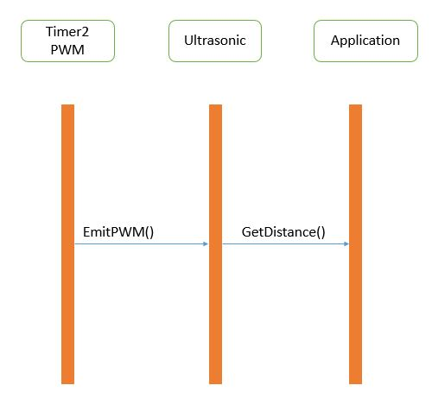

# Shared Resources

There are no shared resources between App module and other modules.

# Configuration specification

This chapter defines configuration parameters and their clustering into containers.

## Containers and configuration parameters

The following chapters summarize all configuration parameters.

### Variants

Configuration variants describe sets of configuration parameters:

### Parameters

None.

# Configuration Constraints

None.

# Integration Constraints

App_Task() function will be called by OS module after finishing of its periodicity time.